Приложение
Раздаточный материал для учащихся
№1. Let’s do some drills first. Read the tongue twisters to yourselves, then read them aloud.
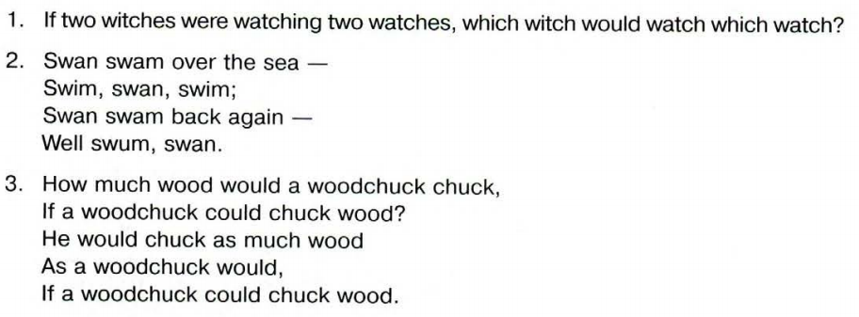
№2
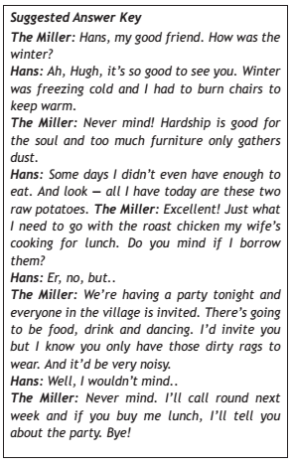
№3. Listen to the dialogue. Pay attention to some words:
Primrose, wheelbarrow, silver buttons, silver chain, wheel-spokes, barn.

№4. http://www.eastoftheweb.com/
№5. Comment on the following statement.

- Some people think that you can have only one true friend.
- The best things in life are free.
What is your opinion? Do you agree with this statement?
Write 200 – 250 words.
Use the following plan:
− make an introduction (state the problem)
− express your personal opinion and give 2–3 reasons for your opinion
− express an opposing opinion and give 1–2 reasons for this opposing opinion
− explain why you don’t agree with the opposing opinion
− make a conclusion restating your position

